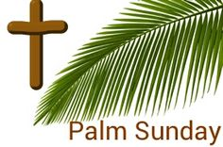
SATURDAY – 23rd March
10.00 am Morning Mass
6.00 pm Vigil Mass

PALM SUNDAY – 24th March
9.30 am Procession of Palms & Children’s Liturgy
11.00 am Procession of Palms & Mass
6.00 pm Evening Mass

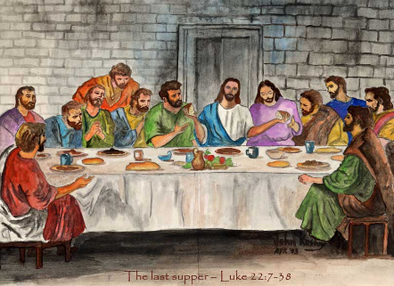
MONDAY OF HOLY WEEK – 25th March
10.00am Mass of Holy Week

TUESDAY OF HOLY WEEK – 26th March
9.00 am Mass of Holy Week
12.00 pm Chrism Mass (Westminster Cathedral)

WEDNESDAY OF HOLY WEEK – 27th March
10.00 am Mass of Holy Week

MAUNDY THURSDAY – 28th March
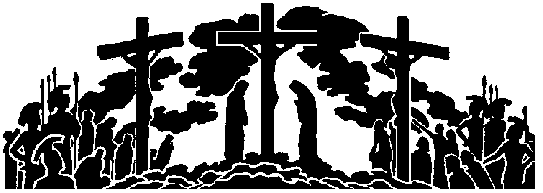
8.00 pm Mass of the Last Supper & Adoration

GOOD FRIDAY - 29th March – No morning Mass
11.15 am Stations of the Cross for Children
3.00 pm Stations of The Cross & Good Friday Liturgy

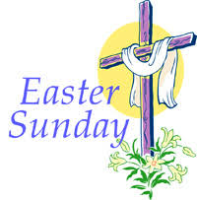
HOLY SATURDAY – 30th March – No morning Mass
8.00 pm Easter Vigil Service

EASTER SUNDAY – 31st March
9.30 am Easter Sunday Mass
11.00 am Easter Sunday Mass
NO EVENING MASS

